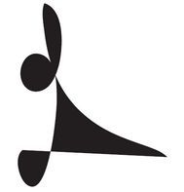

XXII International Festival
of Kiev organization of
National Union of
composers of Ukraine
«Music Premieres of the Season»
Kyiv, May, 22 - 31, 2012

Ministry of Culture of Ukraine
Department of Culture of the Kiev city state administration
National Academy of Arts of Ukraine
National Union of Composers of Ukraine
Kyiv National Union of Composers of Ukraine
State Enterprise "Ukrainian Information Service Center of Culture and Tourism»

The Schedule
(Plan Calendar)
Prologue of festival

Tuesday, May 22, Wednesday, May 23

12.00 State exams of students-composers of the P.Tchaikovsky National Music Academy of Ukraine

State honored pop-Symphony Orchestra of Ukraine
Chief conductor - Sergei Svintsitskyi
Conductor - Mykola Lysenko

Choir of the Kiev Municipal Academic Opera and Ballet Theatre for Children and Youth
Principal Chorus Master - Angela Maslennikova

Works by T.Bila, R.Grygoriv, G.Gusieva, A.Merchel, O.Motsar, A.Pavliuk, I.Razumeiko, A.Stelmach, Ye.Stetsiuk, A.Hataї (Iran),K.Shahrani (Iran) , Tchen’ Yundjia (China)

Chairman of the State Examination Commission – professor of the F. Chopin Music University (Warsaw) and the Academy of Music in Lodz - Zygmunt Krauze (Poland)

Great Hall of the P.Tchaikovsky National Music Academy of Ukraine
st. arch. Gorodetsky, 1-3/11
Wednesday, May 23

19.30 Concert of Sacred Music
B.Lyatoshinsky Classical Music Ensemble
Artistic Director - Valentina Ikonnyk-Zakharchenko
Conductor - Ihor Andrievsky

Works by R. Šіleika (Lithuania), O. Kozarenko

National House of Organ and ChamberMusic of Ukraine
st. Chervonoarmijs'ka, 77

Thursday, May 24

15.00 Concert of winner Winner of the 2-nd All-Ukrainian Ivan Karabits competition of young composers

Concert Hall of the National Union of Composers of Ukraine
st. Pushkinskaya, 32
16.00 Chamber Music Concert
National Ensemble of Soloists of Ukraine "Kyiv Camerata"
Artistic Director and Chief Conductor - Valery Matjukhin

Nathaniel Robin Man (USA) «Donkey Symphony» for five soprano, strings and electronics

Art Arsenal
st. Lavrs’ka, 12

19.00 «Concerto of Concerts»
Contemporary Music Ensemble "Ricochet" and Ensemble «Nostri Temporis»

Works by S.Pilutikov, O.Bezborod’ko, Z.Almashi, M.Kolomyiets, O.Shmurak

House of Scientists of the NAS of Ukraine
st. Volodymyrs’ka, 45

Friday, May 25

Day of Opening of Festival

12.30 Presentation of the CD: "Valentin Silvestrov. Metaphorically music. Borys Demenko, piano"

Concert Hall of the Kyiv Organization of National Union of Composers of Ukraine
st. Pushkinskaya, 32
14.00 Chamber Music Concert

String Quartet Ensemble Modern Music "Ricochet" Kiev National Union of Composers of Ukraine
Works by A.Zymenko, I. Aleksijchuk, B. Kryvopust, R.Aliev (Azerbaijan), P.Kolpakov
Concert Hall of the National Union of Composers of Ukraine
st. Pushkinskaya, 32
17.00 Press Conference
National Philharmonic of Ukraine
Conference Hall
Vladimirsky Uzviz, 2

19.00 Symphonic Music Concert

National Academic Symphonic Orchestra of Ukraine
Artistic Director and Chief Conductor - Volodymyr Sirenko

National Academic Choir of Ukraine "DUMKA"
Artistic Director and Chief Conductor - Yevhen Savchuk

Works by Ye.Stankovich, H.V. Grossmann (Peru– USA), Z.Krauze (Poland), V.Zubitsky

Supported by the Polish Institute in Kyiv
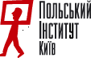
National Philharmonic of Ukraine
Lysenko Concert Hall
Vladimirsky Uzviz, 2

Suturday, May 26

12.00 «Women-composers in film portraits»
Presentation of documentary films
Curator of the project – Ihor Shcherbakov

«The magic of Baku» (Cities of the Future, Episode 1)
Director – Reto Padrutt (Switzerland)
Music by Franghiz Ali-Zade (Azerbaijan)
Co-Director: Cristina Karrer
Cameraman: Laurent Stoop
Cameraman Berlin: Rainer Hoffmann
Editor: Patricia Wagner
«Lesia Dychko»

Director – Oleg Bijma

House of Cinema, Blue Hall
st. Saksaganskogo 6

16.00 Chamber Music Concert

National Ensemble of Soloists of Ukraine "Kyiv Camerata"
Artistic Director and Chief Conductor - Valery Matiukhin

Works by Ye.Stankovich, Yu.Ischenko, E. Airapetian (Armenia), R.Spinosa (Italy), A.Havrylets,V.Silvestrov, V.Zaimov (Bulgaria)

National Philharmonic of Ukraine
Lysenko Concert Hall
Vladimirsky Uzviz, 2

20.00 Electroacoustic music project "Electroacoustics-2012"

Curator of the project - Alla Zagaykevych
Contemporary Music Ensemble "Ricochet" of Kyiv National Union of Composers of Ukraine
Conductor - Victoria Ratsyuk
Artistic Director - Sergei Pilyutykov

Works by M.Pawelek (Poland), A.Zagajkevych, V.Shypulina, M.Shalygin (the Netherlands), O.Retinsky (Switzerland)

Supported by the Polish Institute in Kyiv

National Academy of Arts of Ukraine
st. Vorovs'koho, 20

Sunday, May 27

13.00 Sacred Choral Music Concert

Municipal Academic Chamber Choir «Kyiv»
Artistic Director and Chief Conductor- Mykola Hobdych

Women's Choir «Pavana» of Art Institute of the M. Dragomanov National Pedagogical University
Artistic director – Ludmyla Bayda

Works by S.Dekhtiarevsky, I.Domoratsky, V.Stepurko, V.Silvestrov,

Church of St. Basil the Great
Voznesenskiy Uzviz, 7

15.00 Chamber Music Concert «Alliance»

A joint project of the of Lithuanian Composers’ Union (chairman - Zita Bružaitė) and the National Union of Composers of Ukraine (Chairman - Ihor Shcherbakov)

String Quartet of Kaunas Philharmonic (Lithuania) and String Quartet «Collegium» (Ukraine)

Works by B. Kutavičius, Z. Bružaitė, V. Bartulis, D. Kairaitytė (Lithuania), S.Krutykov, A.Zagajkevych, O.Bezborod’ko, Z.Almashi (Ukraine)
National Philharmonic of Ukraine
Lysenko Concert Hall
Vladimirsky Uzviz, 2

19.00 Gala Concert of Choral Music to the «Day of Kyiv»

Academic Chamber Choir «Khreschatyk»
Artistic director and chief conductor - Pavlo Struts
Municipal Academic Chamber Choir «Kyiv»
Artistic Director and Chief Conductor - Mykola Hobdych

P. Maiboroda Academic Choir of National Radio of Ukraine
Artistic Director and Chief Conductor - Yulia Tkach
Curators of the concert - Lesia Dychko, Anna Havrylets, Ihor Shcherbakov

Works by D.Bortnianski, A.Havrylets, M. Hobdych, L. Dychko, T.Ivanits’ka, V.Ronzhyn, V.Silvestrov, Ye.Stankovich, V.Stepurko, S.Shamo, I. Shcherbakov, L.Jaschenko, O.Levkovych (Canada),I.Bidak, M.Krechko, O.Skrypnyk

National Philharmonic of Ukraine
Lysenko Concert Hall
Vladimirsky Uzviz, 2

Monday, May 28

16.00 Chamber Music Concert of works by composers of Kharkov

Artists - students of I. Kotliarevsky Kharkiv National University of Arts

Works by V.Ptushkin, M.Karminsky, V.Muzhchil’, V.Bibik, O. Shevchenko, V.Zolotuchin, N.Kal’na, O.Pokhylo, D.Kliebanov, V.Drobiazgina, V.Borisov, Ye.Medvedeva, D.Bocharov, D.Malyj, S.Vorobjov

Concert Hall of the National Union of Composers of Ukraine
st. Pushkinskaya, 32
19.00 Symphonic Music Concert

Symphony Orchestra of National Radio of Ukraine
Artistic Director and Chief Conductor - Volodymyr Sheiko

Works by I.Taranenko, V.Antoniuk, N.Rozhko, G.Kuzina, O.Rodin , S.A.Belli (Algeria), V.Samofalov

National Philharmonic of Ukraine
Lysenko Concert Hall
Vladimirsky Uzviz, 2

Tuesday, May 29

14.00 Concert-presentation of new books published by «Music Ukraine» Publishing House: «Karol Szymanowski. «Works for Violin and Piano»

Curator of the project - Bogdan Kryvopust
Foreword – Anatoly Kalenychenko

In the framework a presentation will be performedworks by K. Szymanowski, W.Lutoslawski (Poland)

Supported by the Polish Institute in Kyiv
Concert Hall of the National Union of Composers of Ukraine
st. Pushkinskaya, 32

15.00 Symphonic Music Concert

State honored pop-Symphony Orchestra of Ukraine
Conductor - Mykola Lysenko

Works by V.Gavrik,V.Godziacky, V.Zagortsev, O.Iakovchuk, S.Iaruns’ky

Great Hall of the P.Tchaikovsky National Music Academy of Ukraine
st. Arch. Gorodetsky, 1-3/11

19.00 Chamber Music Concert
National Chamber Ensemble "Kyiv Soloists"
Chief Conductor - Vladimir Sirenko

boys and young men Choir "Dzvinochok"
Artistic director and conductor - Ruben Tolmachov

Works by G.Grigorieva (Estonia), S.Lunjov, V.Poljova, I.Sahbaї (France), O.Tchaikovskiy (Russia), I.Shcherbakov

National Philharmonic of Ukraine
Lysenko Concert Hall
Vladimirsky Uzviz, 2

Wednesday, May 30
10.00 Round table: «Modern Ukrainian Academic Music: status, trends and challenges»
Curators - Galina Stepanchenko and OlenaTaranchenko

Concert Hall of the Kyiv Organization of National Union of Composers of Ukraine
st. Pushkinskaya, 32
14.00 Chamber Music Concert

National Ensemble of Soloists of Ukraine "Kyiv Camerata"
Artistic Director and Chief Conductor - Valery Matiukhin

Works by D.Kitsenko (Canada), V.Vyshynsky, O.Vojtenko, D.Shchyrytsia, T.Iashvili, O.Levkovych (Canada), P.Kolpakov, V.Kyrejko

Concert Hall of the National Union of Composers of Ukraine
st. Pushkinskaya, 32

16.00 Chamber Music Concert

National Ensemble of Soloists of Ukraine "Kyiv Camerata"
Artistic Director and Chief Conductor - Valery Matiukhin

Works by J.Kolodub, V.Runchak, L.Sydorenko, V.Stepurko, B.Froliak

Concert Hall of the National Union of Composers of Ukraine
st. Pushkinskaya, 32

19.00 Closing the Festival

Symphonic Music Concert

National Academic Symphonic Orchestra of Ukraine
Artistic Director and Chief Conductor - Volodymyr Sirenko
Conductor – Natalia Ponomarchuk

Works by A.Zagajkevych, L.Kolodub, O.Shymko, L.Dychko, O.Kostin

National Philharmonic of Ukraine
Lysenko Concert Hall
Vladimirsky Uzviz, 2

Epilogue

Tuesday, May 31
12.00 Concert of Winners of the 3rd Kiev City Competition «Ukrainian Composers - for Children»
The curators of the project - Janna and OksanaKolodub

Concert Hall of the National Union of Composers of Ukraine
st. Pushkinskaya, 32

16. Chamber Music Concert with works by Ukrainian and Greek composers

Julia Uspens'ka (mezzo-soprano), Irina Ryabchun(piano)
The curator of the project - MarynaCherkashina-Gubarenko

Concert Hall of the National Union of Composers of Ukraine
st. Pushkinskaya, 32

17.00 Choral Music Concert «Colors of May»
Academic Chamber Choir «Khreschatyk»
Artistic director and chief conductor - Pavlo Struts
Ensemble of Soloiists’ «Blagovist'»
Artistic Director - Tetiana Kumanovska
Choir of students conductor of choral departmentof Kiev National University of Culture and Arts
Music Director and Chief Conductor - NataliaKrechko

Curator of the concert - Lesia Dychko

National Academy of Arts of Ukraine
st. Vorovs'koho, 20

19.00 Concert of National Orchestra of Folk Instruments of Ukraine
Artistic Director and Chief Conductor – Victo Hutsal

Great Hall of the P.Tchaikovsky National Music Academy of Ukraine
st. Arch. Gorodetsky, 1-3/11

Co-Chairman of the Organizing Committee of the Festival:

Tymofiy Kochan
Deputy Minister of Culture of Ukraine

Ihor Shcherbakov
Musical director of the festival, the President of the National Union of Composers of Ukraine, professor of the National Music Academy of Ukraine, composer
igorshcherb@gmail.com
+380 95 111 81 55 (cell)

Anna Havrylets
Head of the Kyiv National Union of Composers of Ukraine, professor of the National Music Academy of Ukraine, composer
youri1985@gmail.com
+ 380 97337 02 43 (cell)
Members of the Committee:
Lesia Dychko
Secretary of the Board of the National Union ofComposers of Ukraine, professor of the National Music Academy of Ukraine, composer
+380 95 797 72 74 (cell)
Galyna Stepanchenko
Deputy Head of Kyiv National Union of Composers of Ukraine, musicologist
+380 097 242 20 41 (cell)
Mykola Kovalinas
Deputy Head of Kyiv National Union of Composers of Ukraine, professor of the National Music Academy of Ukraine, composer
eidosnouman@gmail.com
+380 68 321 43 57(cell)

Anna Shcherbakova
Art Manager of Kyiv National Union of Composers of Ukraine
an.shcherb@mail.ru;
+380 95 1118150 (cell)
Olena Taranchenko
Member of Bord of the Kyiv National Union of Composers of Ukraine, professor of the National Music Academy of Ukraine, musicologist
shamonin@bigmir.net
+380 67 174 88 86(cell)
Mykhailo Shved
Member of Board of the National Composers Union of Ukraine, Head of musical department of the Ministry of Culture of Ukraine, composer
mshved@yahoo.de
+380 67 247 28 91(cell)
Sergiy Zazhyt'ko
Executive secretary of the Kyiv National UnionComposers of Ukraine, composer
souzkompkiev@gmail.com
+380 44 235 42 45 (office)
+ 380 95 7755499 (cell)
Sviatoslav Krutykov
Member of Bord of the Kyiv National Union of Composers of Ukraine, composer
s.krutykov@gmail.com
+380 67 787 19 78 (cell)
Volodymyr Sheiko
Artistic Director and Chief Conductor of Symphony Orchestra of National Radio of Ukraine
sheiko@nrcu.gov.ua
Olga Golyn'ska
Press secretary of of the festival
mama_olchik@yahoo.com;
zhurnal_muzyka@ukr.net;
ukrcz@ukr.net;
+380 050-35-66-332
+380 093-052-35-51 (cell)

***
Valentyna Glukhot'ko
Chief Accountant - Assistant to the President of the Kyiv National Union of Composers of Ukraine
souzkompkiev@gmail.com
+ 380 44 234 59 59 (office)
+380 67 460 89 65 (cell)

Inna Havrylets
Bookkeeper of the Kyiv National Union of Composers of Ukraine
souzkompkiev@gmail.com
380 44 2345959 (office) +380 50 172 4404 (cell)

Ihor Zakaliuzhnyi
Director of the House of Composers "Vorzel"
btkvrzl@gmail.com
+380 50 544 62 43 (cell)

Vyacheslav (Slava) Prodan
Driver
+380 67 714 59 50 (cell)

Our addreses:

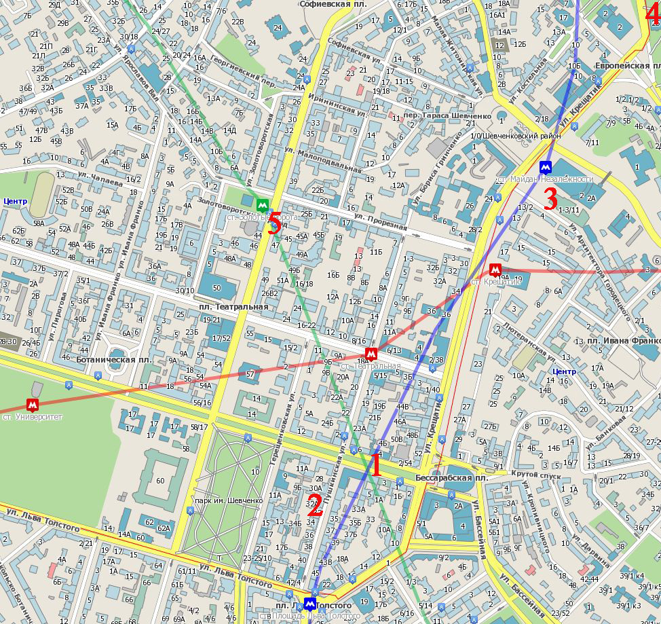

- Hotel Saint-Petersburg. Shevchenko Boulevard, 4
- National Union of Composers of Ukraine, Kyiv organization, concert hall - st.Pushkinska, 32
- Tchaikovsky National Music Academy of Ukraine – st. Arch. Gorodetsky, 1-3/11
- National Philharmonic of Ukraine –
Vladimirsky Uzviz, 2 (European Square)
- House of Scientists of the NAS of Ukraine – st. Volodymyrs’ka, 45

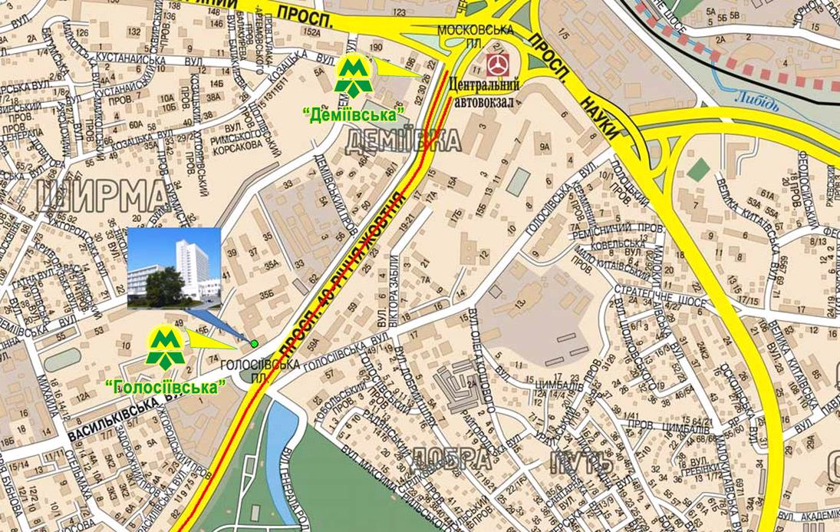

- Hotel "Mir," 40 years of October, 70
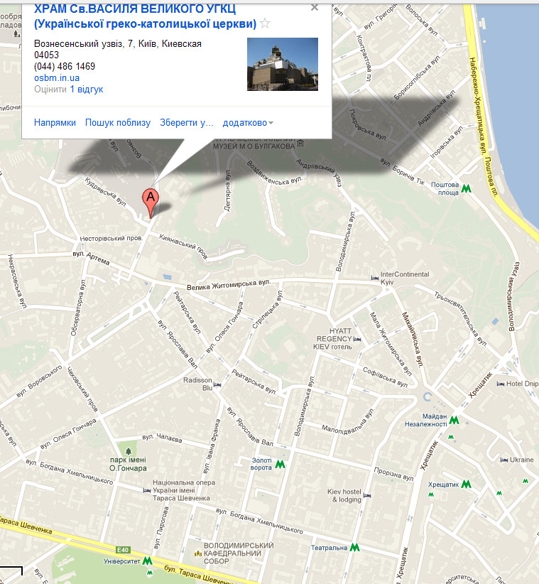
7. Church of St. Basil the Great – Voznesenskiy Uzviz, 7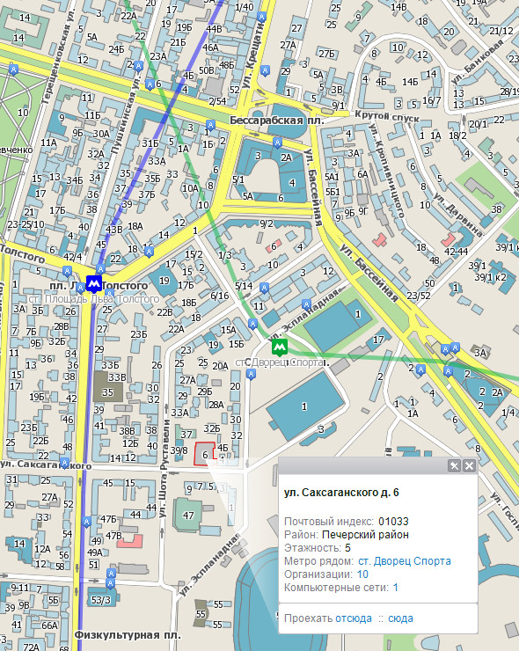

8. House of Cinema – st. Saksaganskogo, 6

